**Experiment No 12**

**Shashwat Tripathi  
D15A 64  
Batch C**

Step 1: Open up the IAM Console and under Roles, choose the Role we previously

created for the Python Lambda Function (You can find your role name

configuration of your Lambda function).

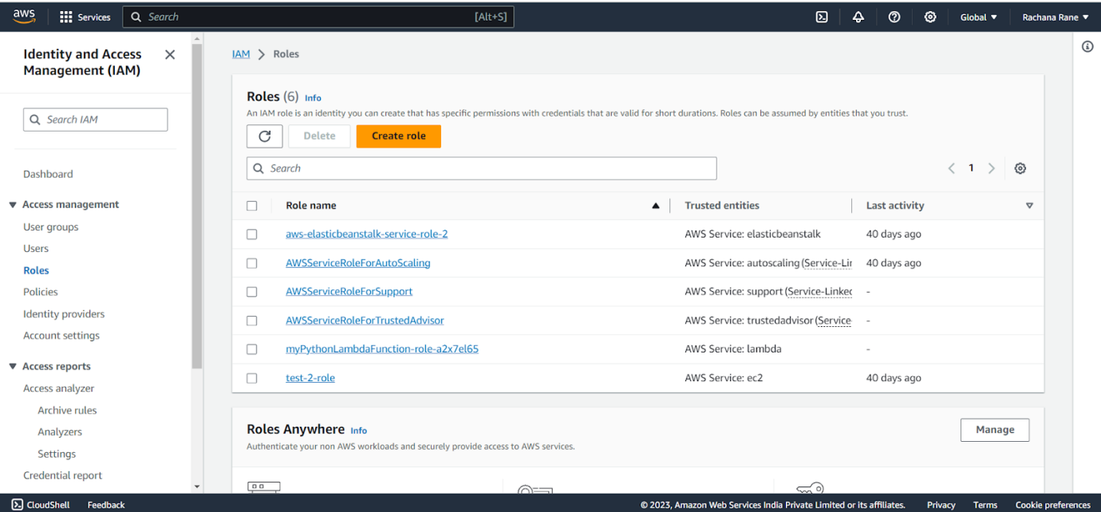

Step 2: Under Attach Policies, add S3-ReadOnly and CloudWatchFull permissions

to this role.

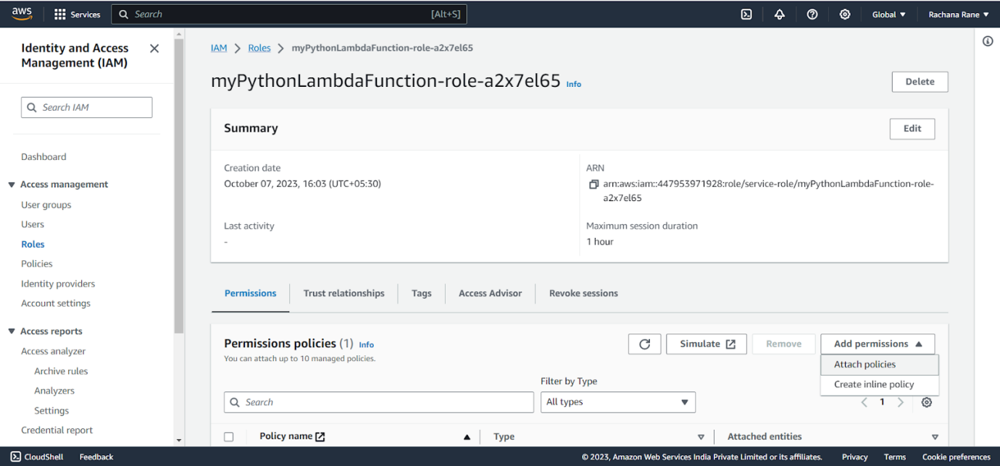

S3-ReadOnly

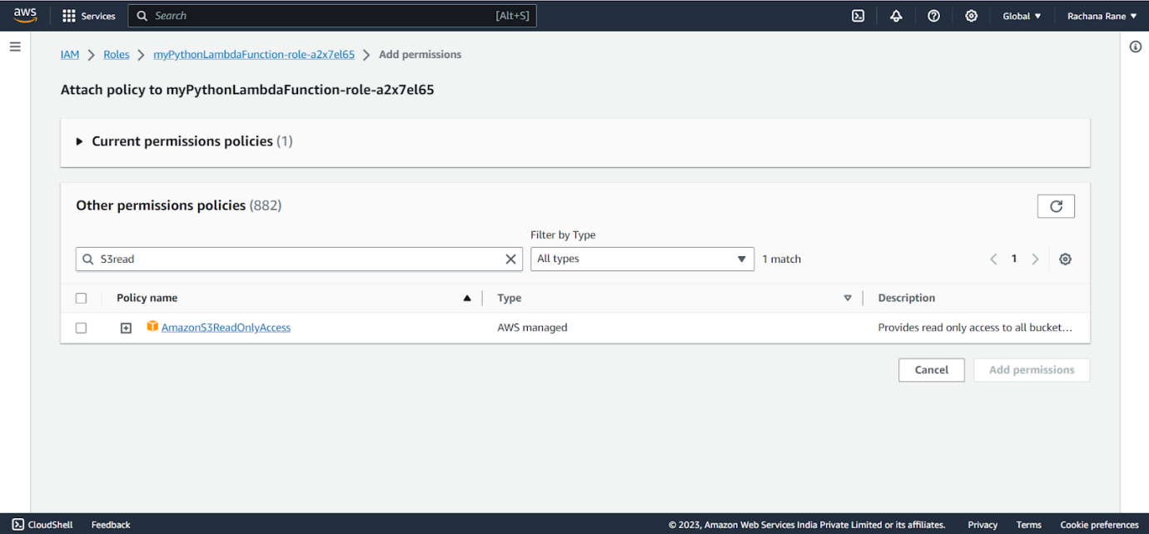

CloudWatchFull

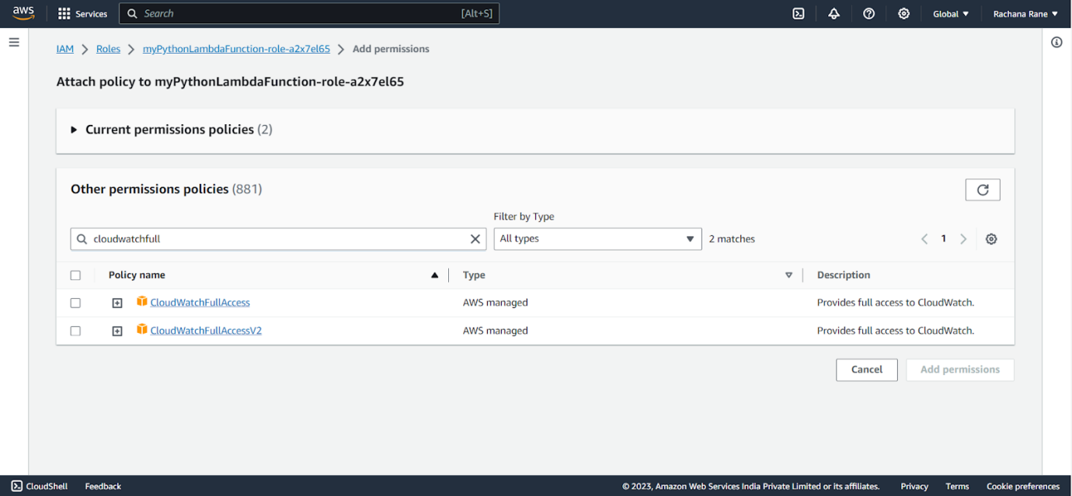

After successful attachment of policy you will see something like this you will be

able to see the updated policies.

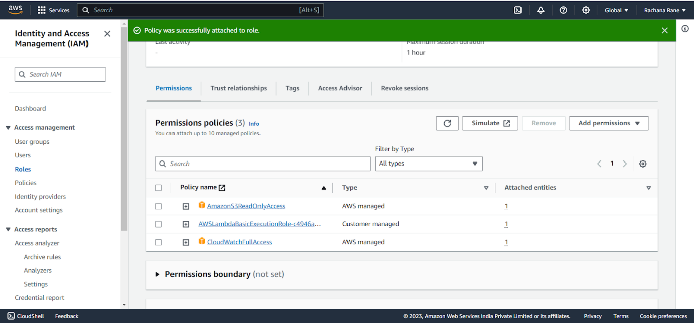

Step 3: Open up AWS Lambda and create a new Python function.

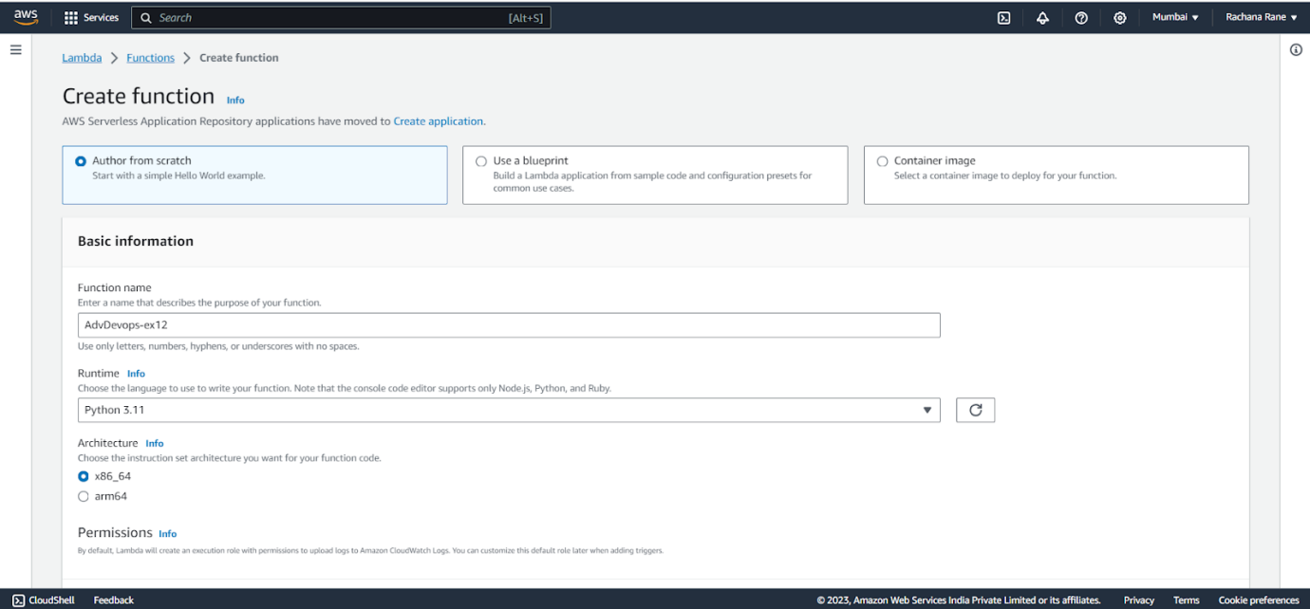

Under Execution Role, choose the existing role, then select the one which was

previously created and to which we just added permissions.

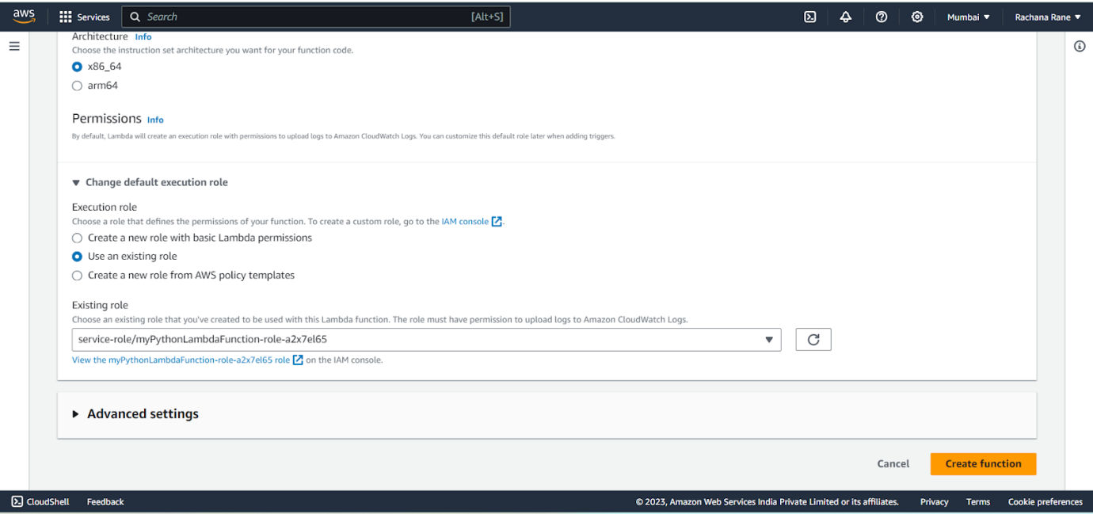

Step 4: The function is up and running.

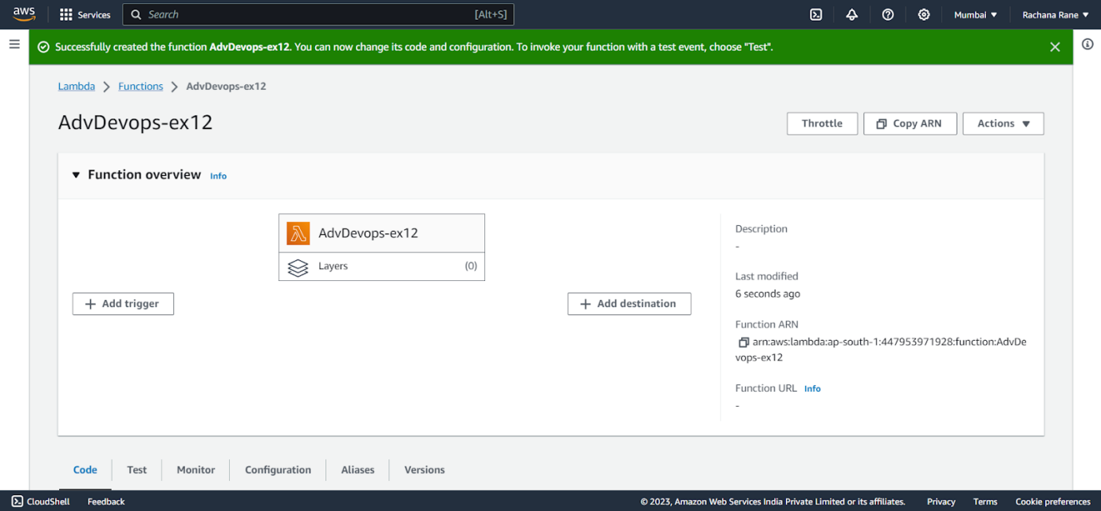

Step 5: Make the following changes to the function and click on the deploy button.

This code basically logs a message and logs the contents of a JSON file which is

uploaded to an S3 Bucket and then deploy the code.

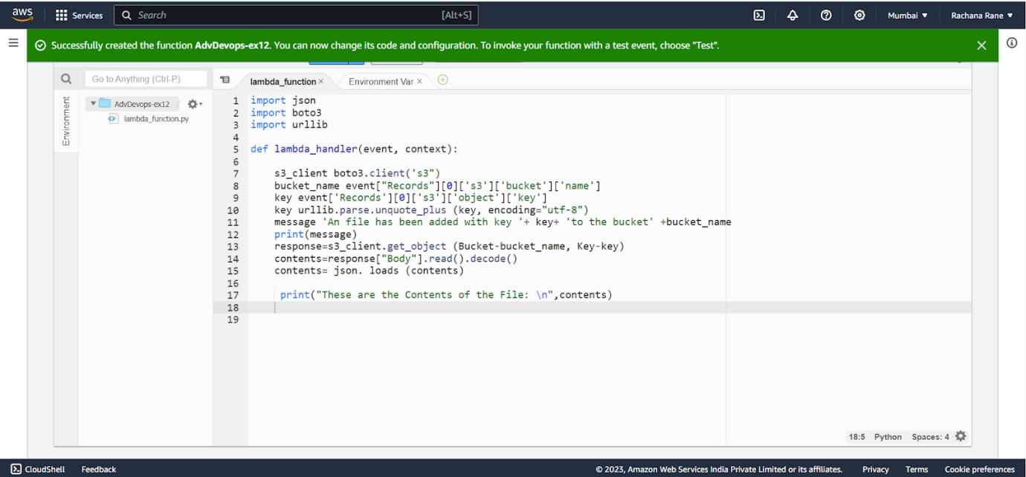

Step 6: Click on Test and choose the ‘S3 Put’ Template.

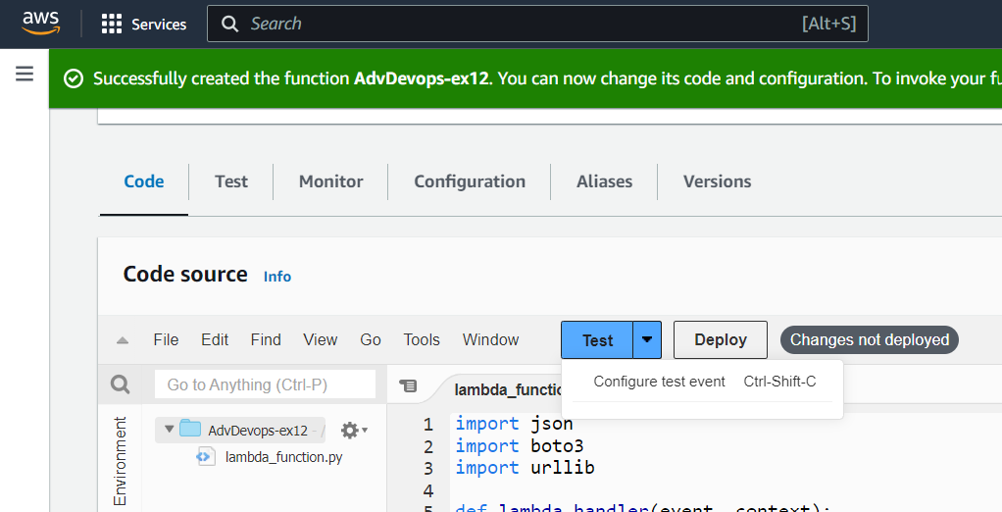

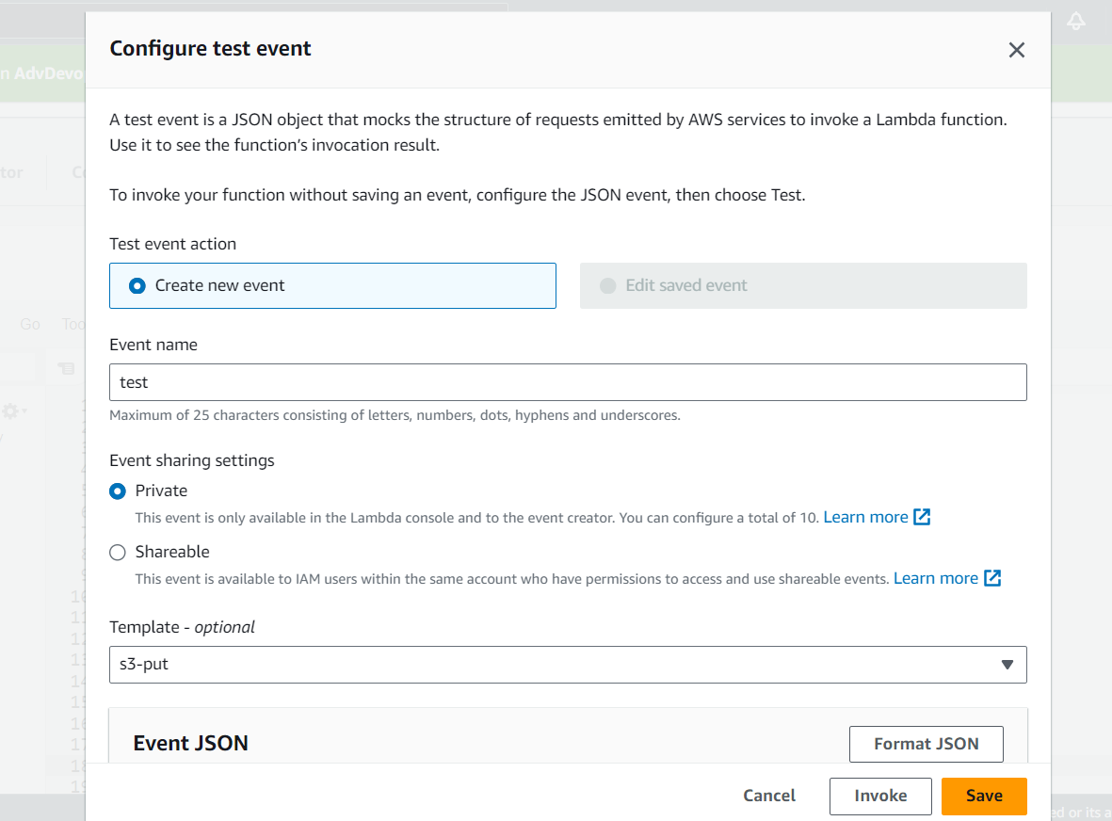

And Save it.

Step 7: Open up the S3 Console and create a new bucket.

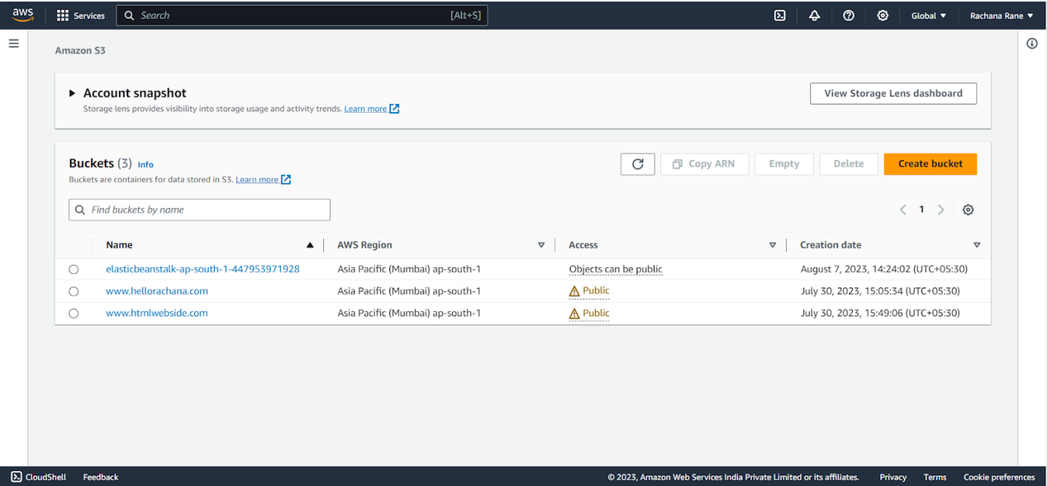

Step 8: With all general settings, create the bucket in the same region as the function.

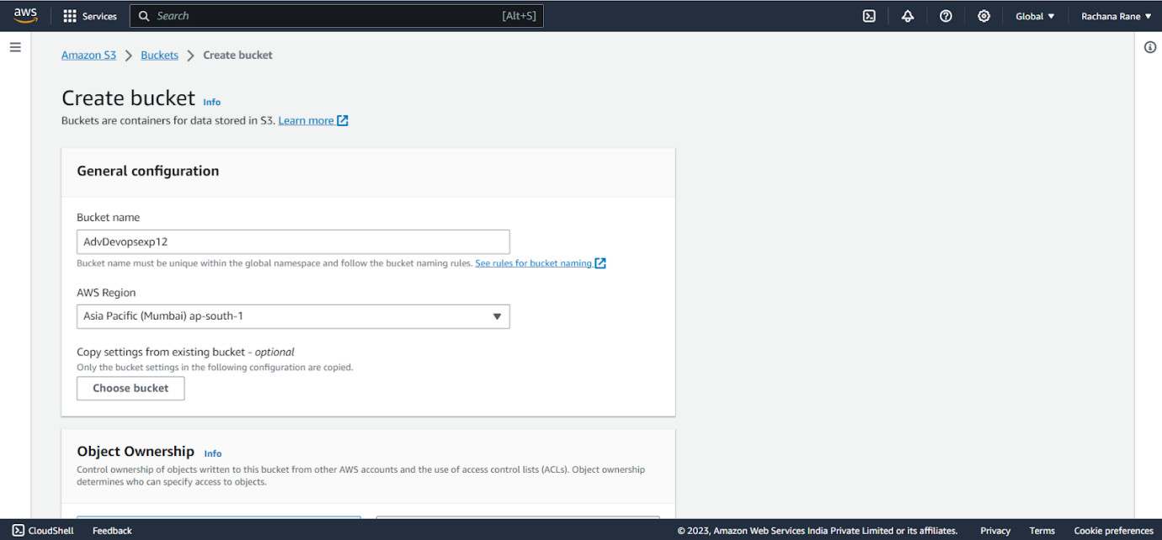

Step 9: Click on the created bucket and under properties, look for events.

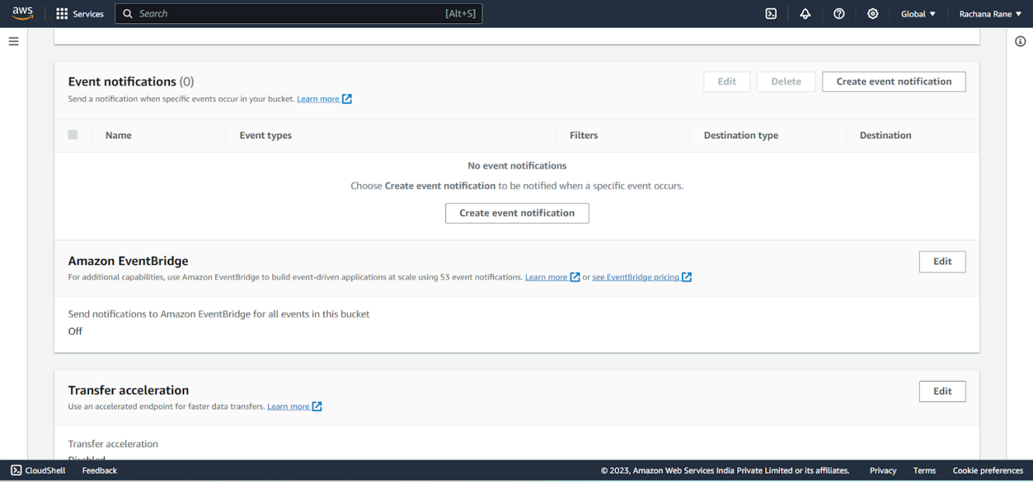

Click on Create Event Notification.

Step 10: Mention an event name and check Put under event types.

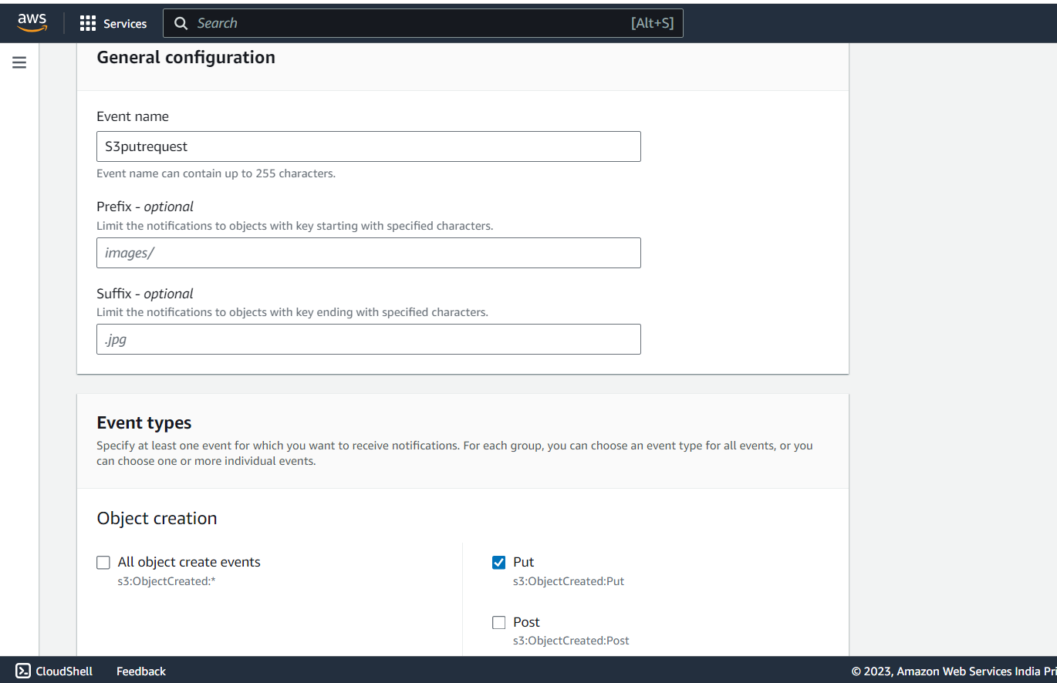

Choose Lambda function as destination and choose your lambda function and save

the changes.

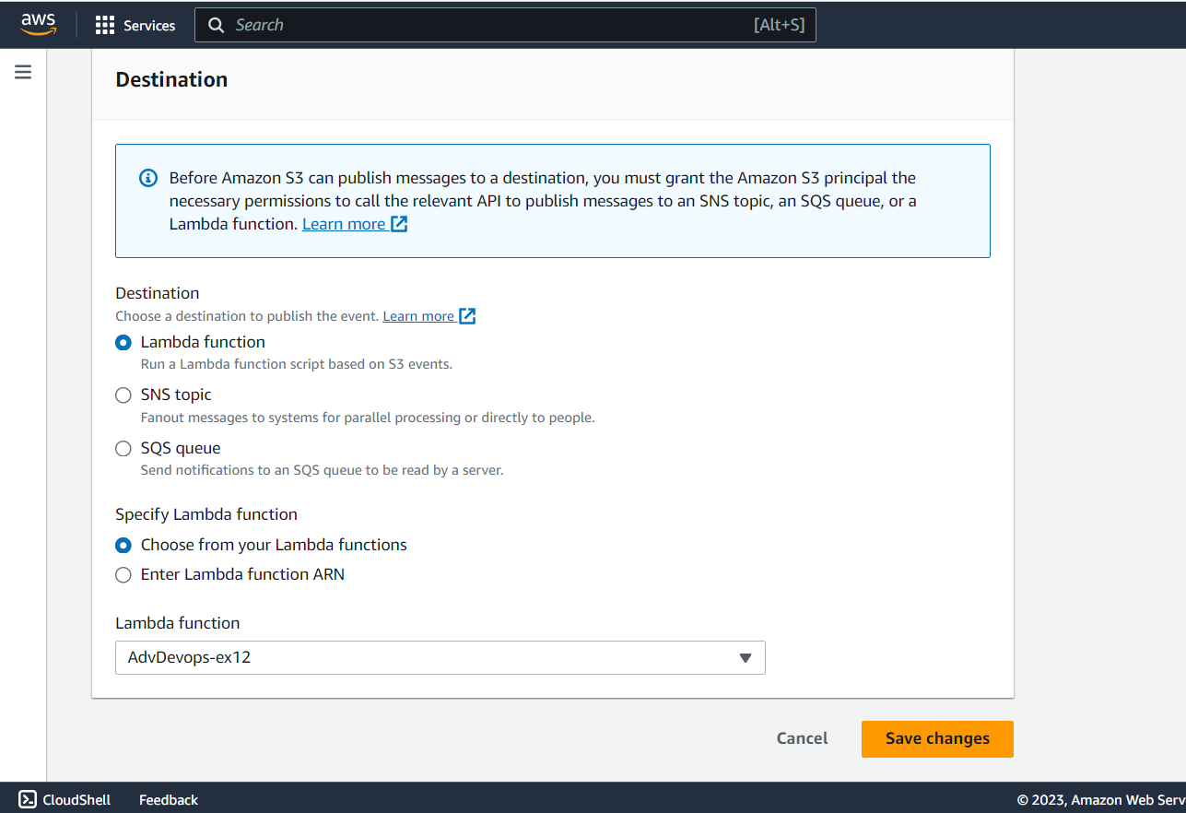

Step 11: Refresh the Lambda function console and you should be able to see an S3

Trigger in the overview.

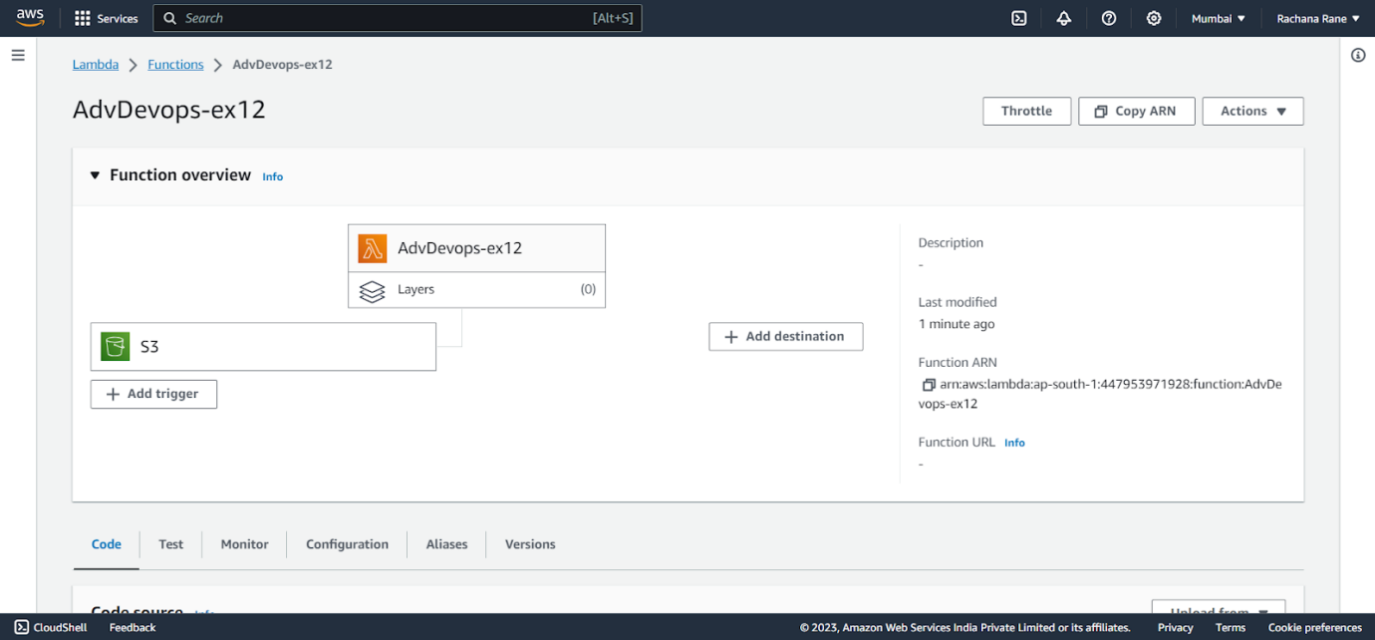

Step 12: Now, create a dummy JSON file locally.

Step 13: Go back to your S3 Bucket and click on Add Files to upload a new file.

Step 14: Select the dummy data file from your computer and click Upload.

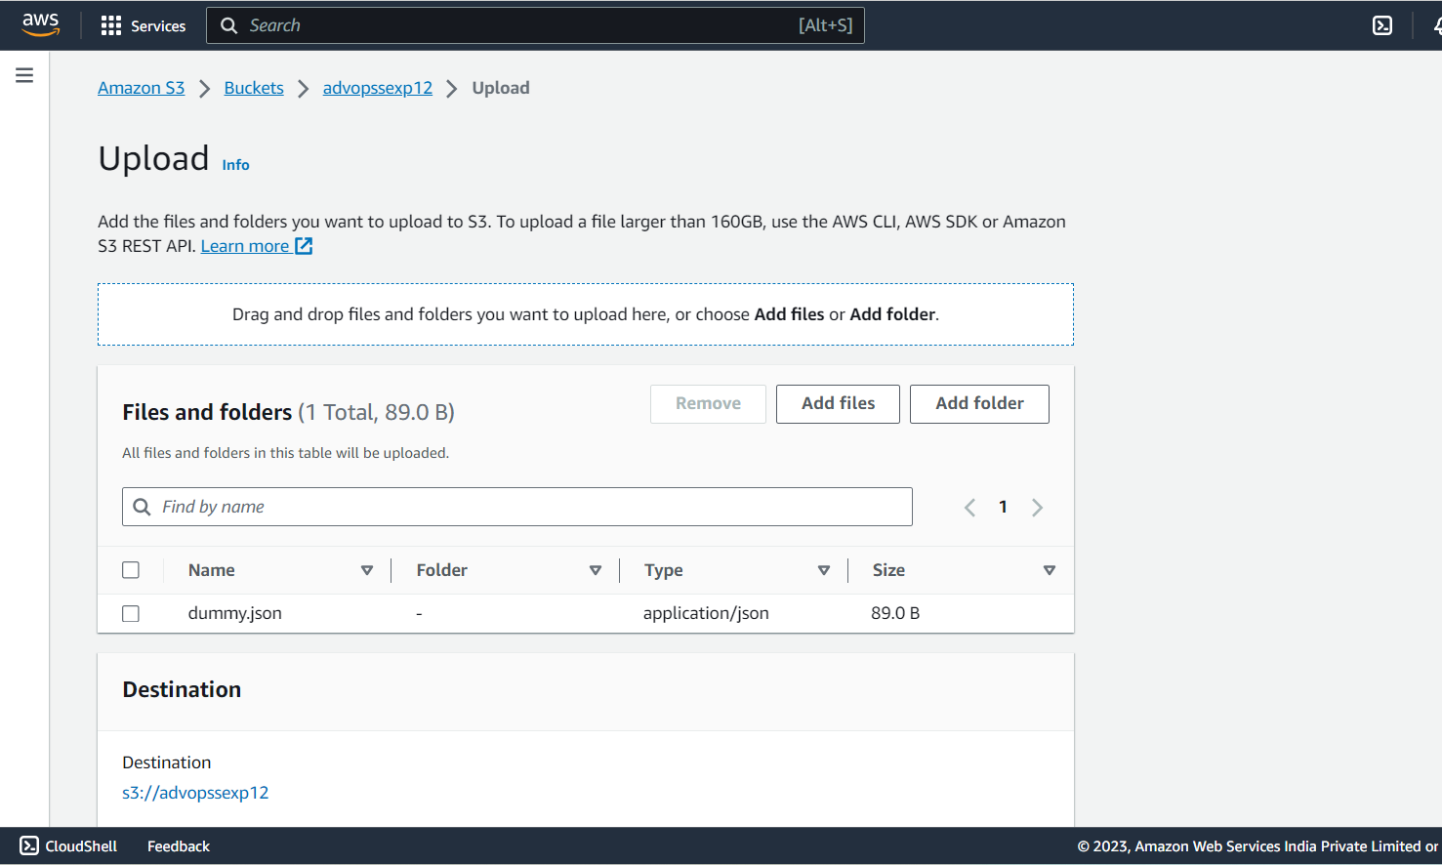

Step 15: After this make the necessary changes in the Test configuration file which

we created it previously by replacing the Bucket Name and the ARN of Bucket.

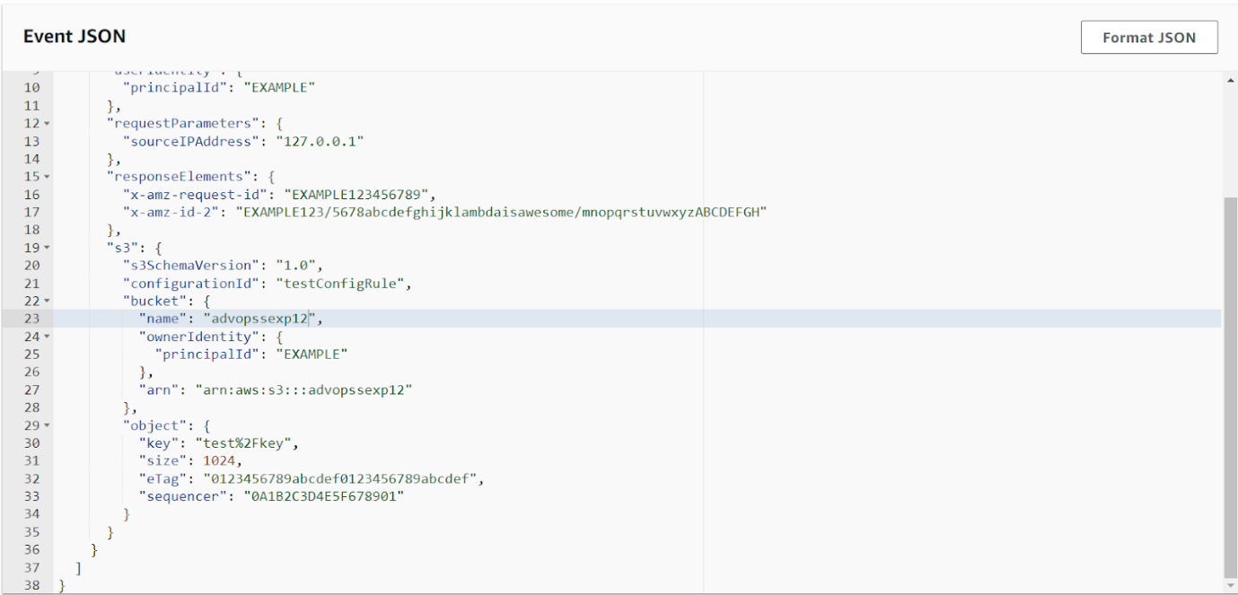

Step 16: Go back to your Lambda function , Refresh it and check the Monitor tab.

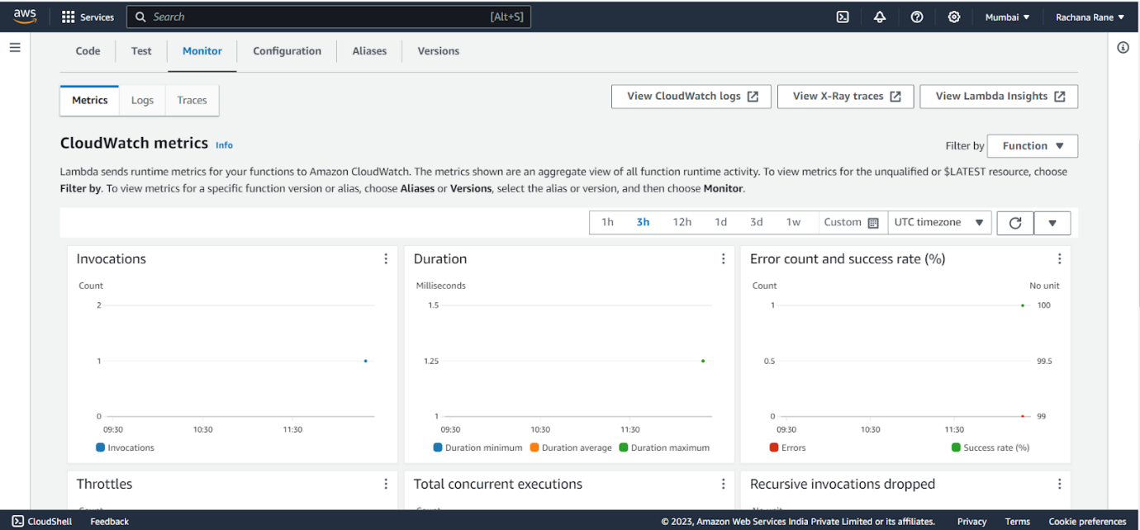

Under Log streams, click on View logs in Cloudwatch to check the Function logs.

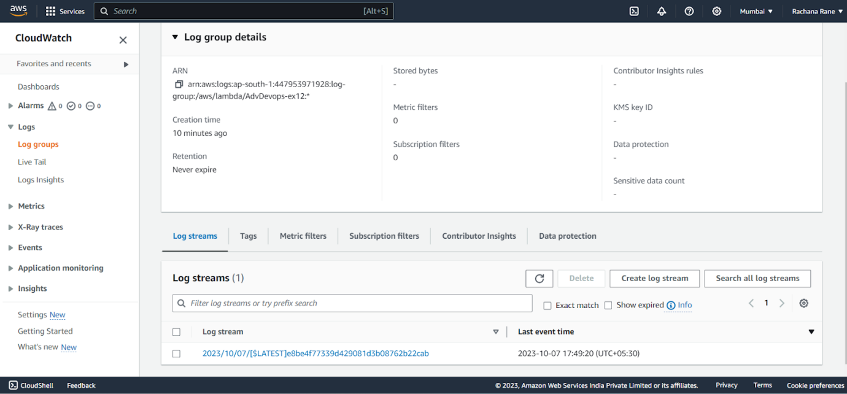

Step 17: Click on this log Stream that was created to view what was logged by

your function.

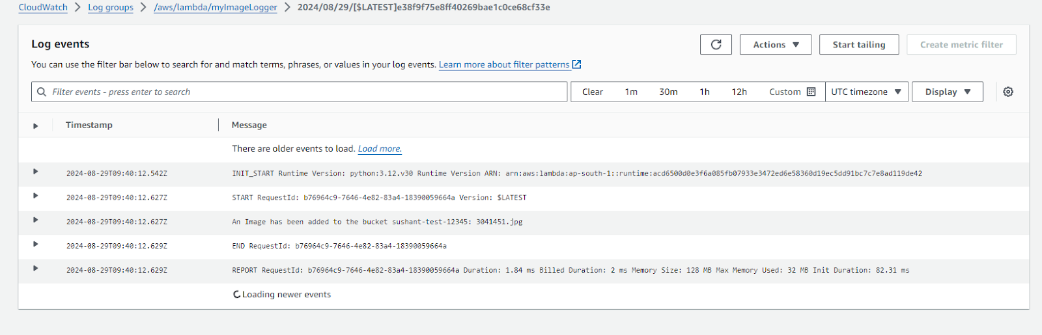

**Conclusion:** Thus, we have created a Lambda function which logs “An Image has been added” once you add an object to a specific bucket in S3.